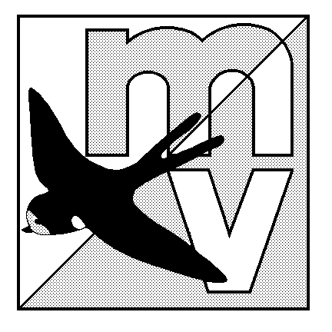 | Mole Valley Orienteering Club  Saturday / Come and Try Series  2008 | 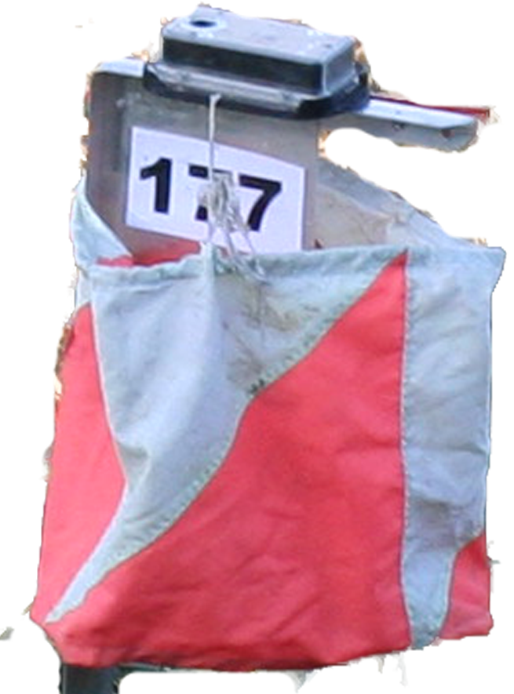

There are 3 events each on a Saturday morning.

Nonsuch Park, Cheam Car park on the south east side of the park, from the A232 Ewell Road.
27th September Nearest railway station is Cheam ½ mile.
Toilets and refreshments in the park.

Hogsmill, West Ewell Car park on South West side of the Recreation Ground accessed from Poole 18th October Road, signed from Chessington Road/Hook Road roundabout.
Nearest railway station is Ewell West ¾ miles.

Redhill Common Car park 1 km south of Redhill, by St John’s School off Fairlawn
1st November Drive, signed from Pendleton Road
Nearest railway station is Earlswood ½ mile

All Events
Please check the Mole Web site (www.mvoc.org) for any important last minute information.

- These courses will be short 2km and 3 km beginner’s courses and a
- 20 Minute Sprint Course for experienced orienteers.

What to expect on the day
There will be Mole Valley Orienteering signs on approach roads.

Experienced orienteers from Mole Valley will be on hand on the day to help and advise those who need it.

You will be provided with a colour map of the course with locations of the points to visit and an electronic punch. After visiting all the points, you download the punch and get a print out of your time.

A full list of results will be added to the Mole Valley web site after the event, we can also post the results to anyone who requests this on the day. You can compare your total and spilt times with all the other competitors.

Entry Fee £1 juniors (under 20 years) and £3 for adults (20 years and over)
Time Turn up on the day between 10.00 and 11.00am there is no need to book
Dogs Are welcome.
Rewards to all junior finishers

Officials Nonsuch Hogsmill Redhill
Organisers: Jackie Olive Jackie Olive/Peter Martin Jackie Olive/Bill Alexander
Planners: Graham Sutton Ian Ditchfield Bill Alexander/Simon Alderdice
General Enquiries info@mvoc.org

COMPETITORS PARTICIPATE IN THIS EVENT AT THEIR OWN RISK

